SWE40002 – Software Engineering Project B

Semester 2, 2018

End of Semester Self-assessment

Name: Shenal Nirushka Samarasinghe

Student ID: 101054998

Team #: 21

Project Name: Smart-glass based remote guidance system

## Introduction

The purpose of this report is to clearly communicate my individual outcomes for the unit SWE40002 – Software Engineering Project B. This report has been structured to include self-assessment details to support the grade outcome I believe I have attained, a summary list of specific major supporting evidence including an analysis of my activities, a detailed presentation of the alignment between the evidence details with the learning outcomes, and a personal reflection on the overall learning and outcomes.

## Self Assessment

**Roles and responsibilities**

* Oversaw the Usability Design and testing
* Lead a sub group of 3 member to complete the code for tracing coordinates
* Worked on the technical documentation
* Carried out Manual testing
* Carried out Useability testing

**The grade I am trying to achieve**

HD

**Summary of what I achieved**

We were successfully able to implement the system as per the client’s requirements, to do this I had to learn openCV and how to use node JS. I was able to successfully complete the sections of the code that I was responsible for and I was able to do it in a way that it could be integrated with the rest of the code without any issues. I also was able to organize and carry out the Useability test with the help of another team member. I also designed and carried out the manual testing with the help of another team member. I helped the leader with organizing the tasks towards the end of the semester. I also did refactor and code reviews for some sections of the code. In addition to this I have taken part in another of other minor tasks too. One of the more time consuming tasks that I did was when I worked with a few other team members to get the tracing to work, we spent 30+ hours trying various ways of implementing the tracing . We did not do to much documentation this semester as most of it was done last semester.

## List of Contributions

|  |  |  |
| --- | --- | --- |
| Item | Link | Time Spent |
| Code for to find the pointer coordinates | <https://github.com/suraz24/SWE40001-Smart-Glass/blob/integration/src/GetTraceCoordinates.js> | 15 hours |
| UCD Documents- operator task description | <https://docs.google.com/document/d/1D1jjm7lJ9uLpyH7qtSXn8k_EPokVb5nwGGBPlQ9XSZ4/edit?usp=sharing> | 1 hour |
| UCD documents – Demographic questionnaire | https://drive.google.com/open?id=1nkB80hq9TvgeXs-ZmWJLkDi8ljy2xZret4V-k0NVFfA | 15 mins |
| UCD documents – satisfaction questionnaire | https://drive.google.com/open?id=1mWIPzCdpz_T9MpoYAwf025j3ON6Y3D8plBwxDatEup0 | 15 mins |
| UCD documents – Instructor task description | https://drive.google.com/open?id=1M-dQDPT7KljWYVG8Z6iOYyfbdJsHQRDd78Bjgl5mC74 | 1 hour |
| UCD documents – Evaluation informed consent | https://drive.google.com/open?id=13cMt5oGuE12wpovjn4jquqR3kXcuD2aMGXrQImhuSwQ | 1 hour |
| UCD documents – Instruction sheet | https://drive.google.com/open?id=1dnu5DyP60e17grojjDtPInxtFAiB8R7JR2OikYIUIdQ | 30 mins |
| Technical documentation | https://docs.google.com/document/d/1qhkKODccdAG3F_gxkO6Sl2kqe1AJTfrr1nfBx4Pm3uM/edit?usp=sharing | 3 hours |
| Manual testing | https://docs.google.com/document/d/1EZpWVLd-5qku6aQkAhuyuxFIMl0Xa3n4BqQkfA9gBS0/edit?usp=sharing | 4 hours |
| refactoring | https://github.com/suraz24/SWE40001-Smart-Glass/blob/integration-refactor/src/FrameTrace.js | 10 hours |
| Tracing | https://github.com/suraz24/SWE40001-Smart-Glass/blob/integration-refactor/src/FrameTrace.js | 25 hours |
|  |  |  |

Work Log

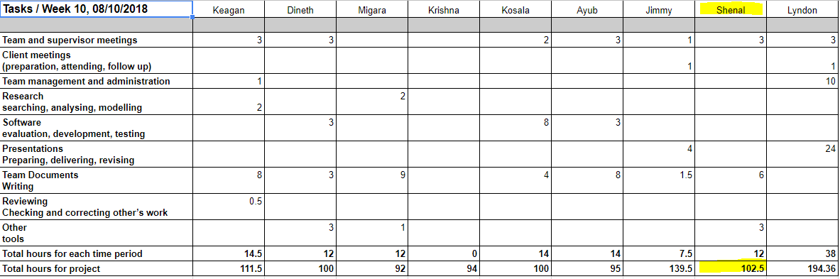

## Learning Outcome Assessment

When we were writing the code for the coding I was put in charge of a team consisting of me and 2 other members, after we finished the coding I was again in charge of this team to do the usability and manual testing ,through this I have satisfied the ULO 3 as I had to communicate effectively between the member to get the tasks organized. As mentioned here I worked on the code to get the pointer coordinate and helped with the code for the tracing during this process I has to use software engineering methods and had to use tools like OpenCV, git repository’s and nodejs framework.by doing so I believe I have satisfied the ULO 2.I too part in professional practices like meetings and stand ups as well as taking a professional approach to the usability testing, by properly documenting the process and documenting user consent, through this I have fulfilled ULO 1. Since I was not familiar with OpenCV or nodejs I had to do a considerable amount of research in order to be able to write the code, but doing so I have fulfilled ULO 4

* 1. **Product**

|  |  |  |  |
| --- | --- | --- | --- |
| Contribution | Description | Estimated % of the total product | Which client requirements does each address? |
| Code for to find the pointer coordinates | It the the code that will identify the pointer and then provide the coordinates of the center of the pointer for each frame that is sent to it | 20% | Tracing |
| Code for to find the pointer coordinates | We had issued implementing the tracing so me and some other members spent a large amount or time trying to implement it in various ways, | 25% | Tracing |

|  |  |  |  |
| --- | --- | --- | --- |
| Contribution | Which software design does each address? | Estimated % completion against the design | Period of activity |
| Code for to find the pointer coordinates | Trace coordinates | 100% | week 5 to 7 |
| Code for to find the pointer coordinates | Tracing | 80% | week 7 to 9 |
|  |  |  |  |

* 1. **Process**

.

|  |  |  |  |
| --- | --- | --- | --- |
| Demonstration | Description | Estimated % of the total assignment | Which section of SQAP does each address? |
| Usability documents linked above | I was the champion for Usability and GUI therefore i have followed the standards set by in the SQAP | 5% | Champions |
| Code for Tracing/coordinates  <https://github.com/suraz24/SWE40001-Smart-Glass/blob/integration/src/GetTraceCoordinates.js> | I have followed the coding standards set in the SQAP | 30% | Coding standards |
| Manual Testing  https://docs.google.com/document/d/1EZpWVLd-5qku6aQkAhuyuxFIMl0Xa3n4BqQkfA9gBS0/edit?usp=sharing | Do do the manual testing i have followed the testing guidelines on the SQAP | 5% | Testing |

|  |  |  |  |
| --- | --- | --- | --- |
| Demonstration | deadline as set in meeting | Date started | Date Completed |
| Code for tracing/coordinates | end of week 8 | 03/09/2018 | 24/09/2018 |
| Usability testing | Week 9 | 24/09/2018 | 01/10/2018 |
| Manual testing | Week 10 | week 10 | Week 10 |

* 1. **Involvement**

**Note : i have not included activities from the previous semester**

|  |  |  |  |
| --- | --- | --- | --- |
| Activities | Description | Type  (Internal/External) | What is your role in the activity? |
| Supervisor meetings/team meetings | Attended most of the supervisor meetings | Internal | Group member |
| Coding trace Coordinates | Writing the code for the trace coordinates | Internal | Programmer/leader |
| Coding the tracing function | Help implement the tracing function | Internal | Programer |
| UCD testing | Conducting the Usability test and preparing the documents | Internal | Conducting the usability tests |
| Manual Testing | Prepared manual testing documents and conducted testing | Internal | IN charge of carrying out the testing |
| Refactoring |  | Internal | Code revoew |

|  |  |  |  |
| --- | --- | --- | --- |
| Activities | Role (Chair/Lead/Contributor) | Type  (Internal/External) | What was your contribution? |
| Coding trace Coordinates | Lead | Internal | programmed the major fucntions and lead the group |
| UCD testing | Lead | Internal | Organized and conducted Usability tests |
| Manual Testing | Contributor | Internal | Conducted the manual testing,Wrote the manual testing documents |

Total and summarise your involvement in the table below

|  |  |
| --- | --- |
| Total number of presentation feedback provided | 8 |
| Total number of activities | 11 |
| Total number of internal and external related activities | 11 |
| Percentage of contribution | 70% |

## Reflection

### The most important things I leant:

*Learning how to Work well with a team*

*How to communicate effectively*

*Leading small groups*

*Coding practises*

### The things that helped me most were:

*Code reviews*

*Communication Standards*

### I found the following topics particularly challenging:

*Coding using openCV as it is my first time using openCV*

### I found the following topics particularly interesting:

*Usability testing and Coding the tracing function*

### I feel I learnt these topics, concepts, and/or tools really well:

*How to use Git*

*Coding Practices*

*Code Reviewing*

### I still need to work on the following areas:

*Documentation*

*Formal Communication*

### My progress in this unit was …:

*My progress in this unitt this semester started slow but towards the the middle i was able to progress fast*

### This unit will help me in the future:

*The experience gained working with a large team*

*Learning the proper industry standards*

### If I did this unit again I would do the following things differently:

*Spend more time learning OpenCv so i would be able to contribute even more towards the code*

## Conclusion

In summary, I believe that I have clearly demonstrate that my outcomes are sufficient to be awarded D grade.